D4 Hot Diode Investigation

Sometimes, random Delta4 diodes show up very, very hot in the D4 software when we shoot DQA on E1. We thoroughly investigated the issue circumstances with the same DQA plan shot in different ways on both E1 and E2. We have only even seen the problem with SBRT plans.

# Run #1: E1

## Beam 1: 2 random hot diodes

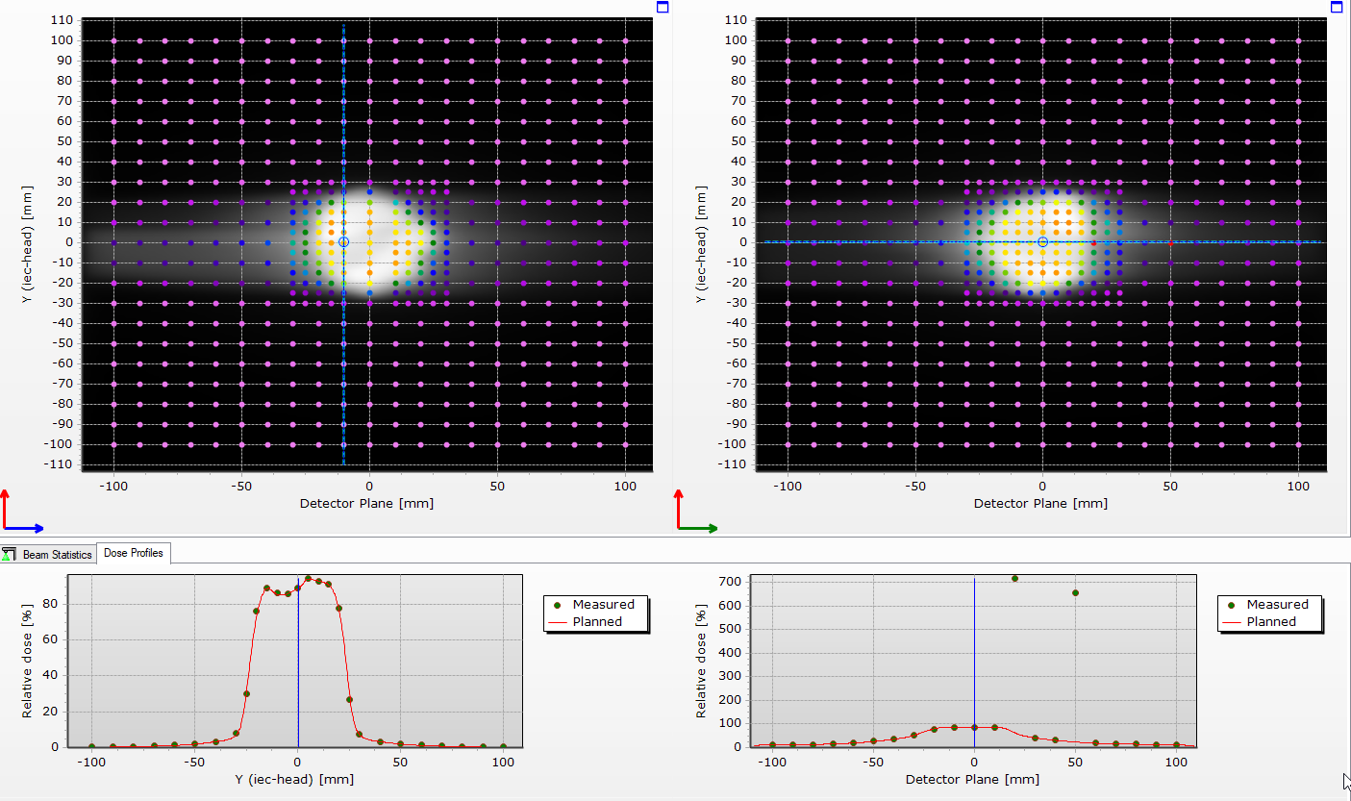

## Beam 2: normal

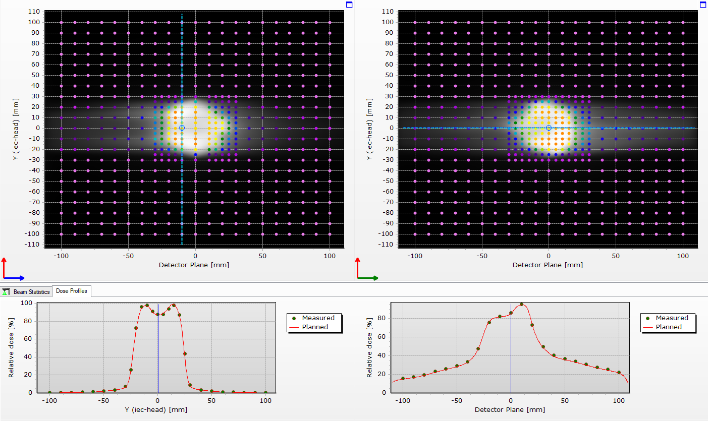

# Run #2: E1

## Beam 1: normal

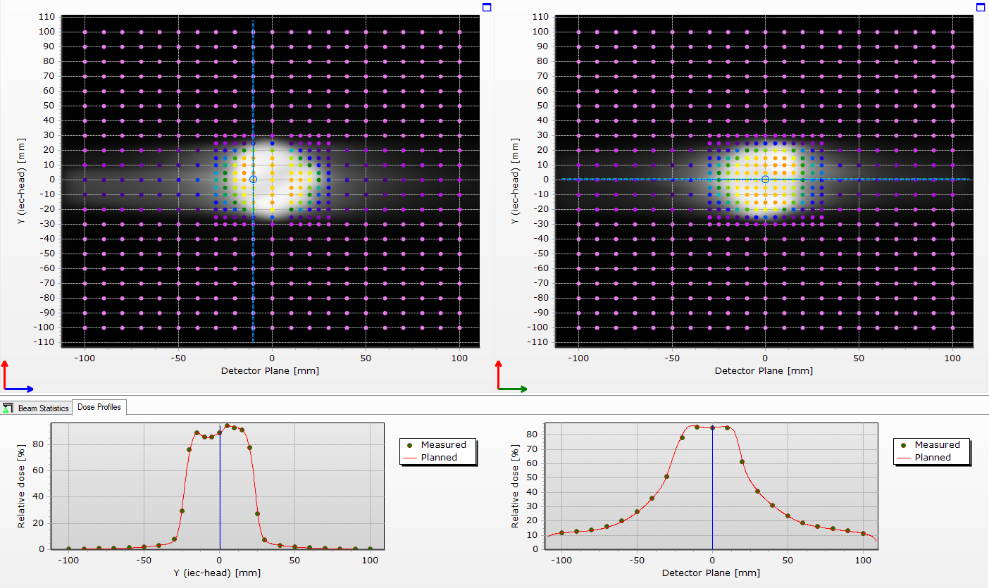

## Beam 2: normal

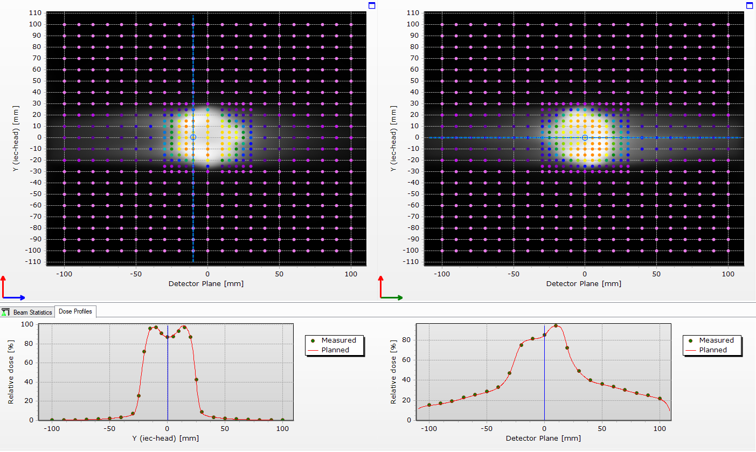

# Run #3: E1

In run #2, we rescaled and optimized beam 1 before shooting beam 2. Could this have caused the hot diodes now to show up in the software? Seriously doubt it, but we again ran the whole plan before rescaling/optimizing, just to double check.

## Beam 1: normal

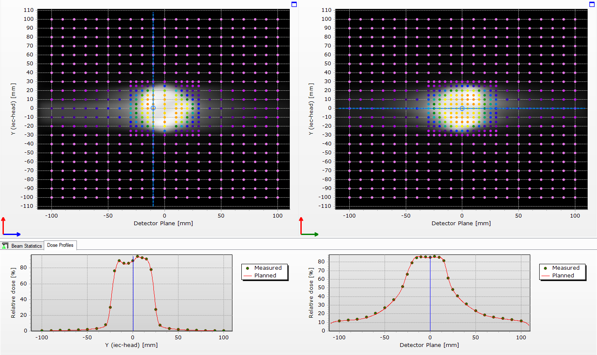

## Beam 2: 1 random hot diode, distinct from the 2 hot diodes from beam 1 in run #1

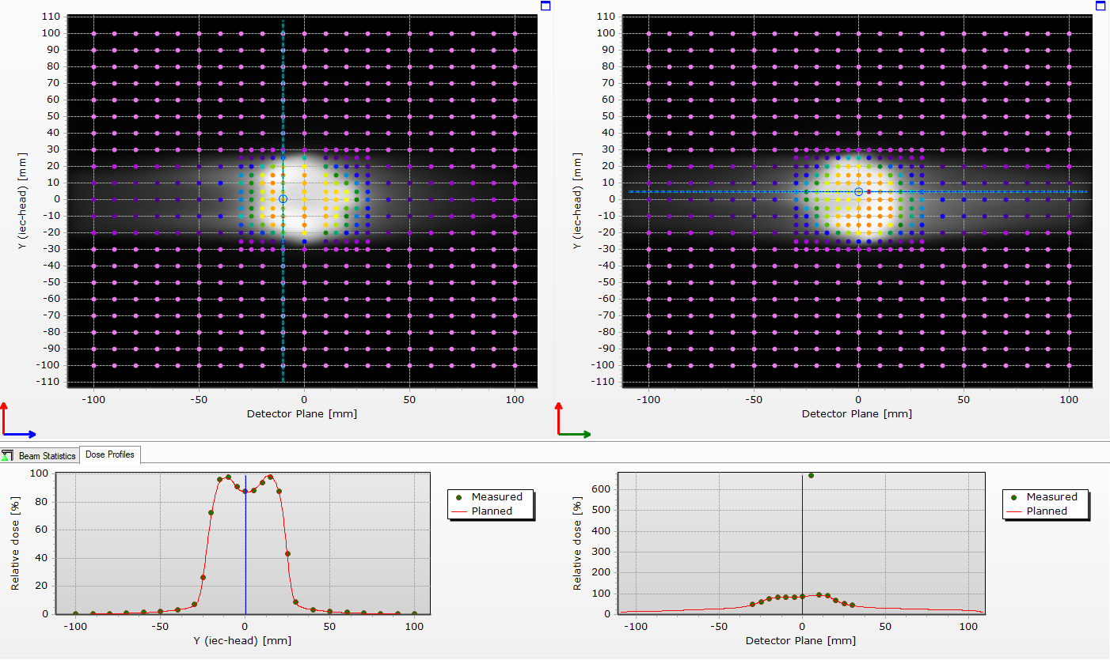

# Run #4: E2

We’ve only ever seen the issue on E1, and this time was no different.

## Beam 1: normal

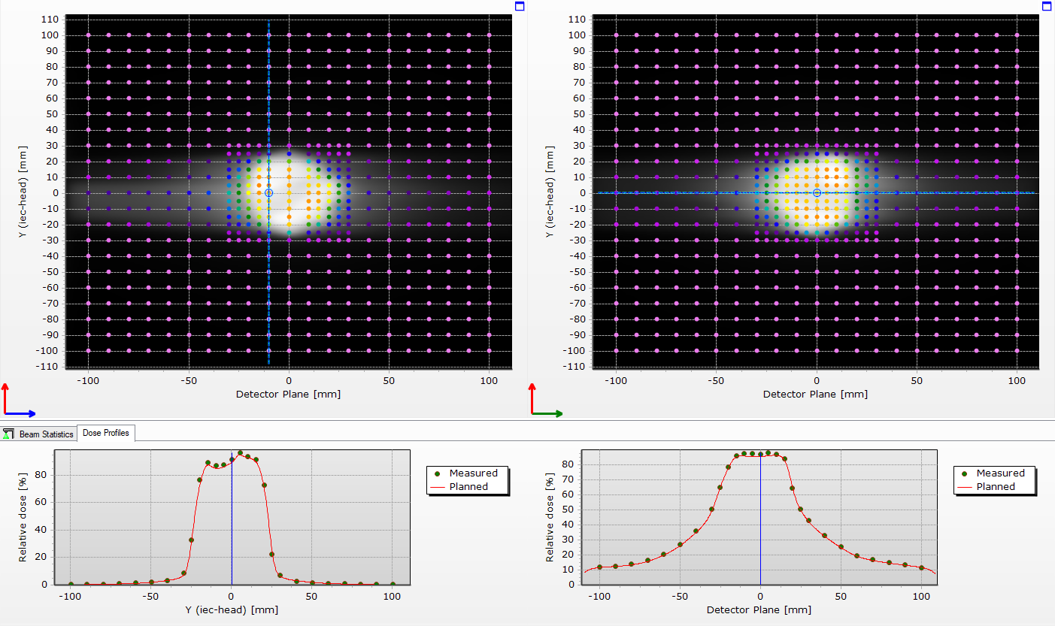

Beam 2: normal

